**Analysts**: Matthew S., Nathen S., Justen Z. **Contact Info**:mws6037

**Team name: JMN 231**

**Prepared for: Date Prepared**:11-1-2015

**Purpose: To assess the series of bank robberies in January 2015**

**Title:** Report Summary, Case of the Red Hat Robbers

**Key Question:** Who are these robbers? /Are these incidents all separate?

**1. BLUF:** Starting on January 12th a series of bank robberies occurred through January of 2015. These robberies were all within State College PA. The robberies ranged from unarmed to armed in groups, with 1 failed unarmed attempt. These locations were all hit essentially within a week and had money stolen from a range of $0 - $22,000. A white van has been seen assisting in many of these robberies. Most robberies were committed by white males wearing a red hat or ski mask, it is believed that these robberies were committed by an organization called the Red Hat Robbers.

**2. Assumptions:**

* The Red Hat Robbers were all in an organization
* White van seen escaping in many robberies is the same van through all cases
* Red hat/ski mask is a group signature
* All suspects are white males

**3. ANALYSIS of Findings:**

* In every bank job at least one witness noted the red headgear of a suspect.
* Suspects have all been identified as Males
* Some banks did not have video surveillance at the time of the attack
* White work van seen in many incidents to assist in suspect's escape

**4. Conclusion:** Starting on January 12th a series of bank robberies occurred through January of 2015. These white male suspects have hit many banks in State college within a week's time and they all have a common trait, the red headwear. They are believed to be a single organization targeting State College’s banks.

**Network (Canalytics)**

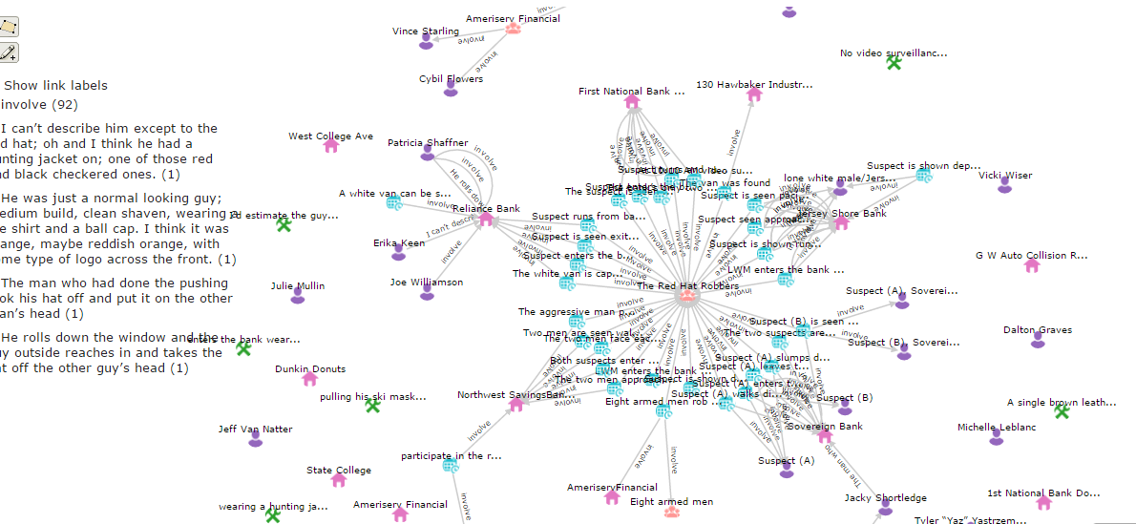

**Evidence Matrix**

|  |  |  |  |  |  |  |
| --- | --- | --- | --- | --- | --- | --- |
| **Case Number**  **Date/Time** | **Bank Name/**  **Address** | **Amount Stolen** | **Suspect(s) Description** | **Witness List** | **Evidence by Type** | **Notes/Inferences** |
| 001  12 Jan,  1625 hrs | Jersey Shore Bank/2050 N. Atherton St. State College, PA | $1,025 | a red hat very low over his face and had brown beard, lone white male | * Erin Hecker * Mark Haley | * Street Video Surveillance |  |
| 002  12 Jan,  1715 hrs | Reliance Bank/100 Hawbaker Industrial Dr. SC, PA | $3,050 | Male, between 5’-10” and 6’-0” tall, probably 180-200 lbs, mousey brown hair, facial hair | * Erika Keen * Joe Williamson * Patricia Shaffner | * Video surveillance |  |
| 003  14 Jan,  2103 hrs | Sovereign Bank/ 216 W. College Ave. SC, PA | $1,875 | Male, medium build, clean shaven, wearing a tee shirt and a ball cap(red) | * Sean McQueen * Jacky Shortledge | * Video surveillance * Physical Evidence |  |
| 004  15 Jan,  2215 hrs | First National Bank Downtown/ 117 S Allen St. SC, PA | $0 (Failed) | Red ski mask, Male | * Tyler “Yaz” Yastrzemski * Julie Mullin * Chris Clark | * Parking area video surveillance | * The interior video surveillance was erased. Had a red ski mask |
| 005  18 Jan,  1645 hrs | Northwest SavingsBank/ 1767 N Atherton St. SC, PA | $1,550 |  | * Michelle LeBlanc * Mike Holden * Jeff van Nader | * Witness * Bank manager | * The bank’s interior cameras were inadvertently erased. |
| 006  20 Jan,  2345 hrs | Ameriserv Financial/ 734 S Atherton St. SC, PA | $18 - 22K | Two, 3-man teams: all wearing red ski masks | * Cybil Flowers * Reed Davis * Vince Starling | * Witness | * There is no video surveillance since the tapes were removed and the robbers disabled the recording device. * There was a secondary recording device located outside, but was not operational during the heist * Two, 3-man teams |
| 007  22 Jan,  1413 hrs | Citizen’s Bank/1248 S Atherton St. SC, PA | $800 | heavyset guy with bright red hair, wearing work overalls, red hat | * Vicki Wiser * Dalton Graves * Searle Spence | * Witness | * The robbery was not caught on tape, hat not over face. |
|  |  |  |  |  |  |  |
|  |  |  |  |  |  |  |